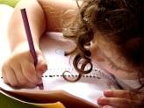  Literacy  In literacy we will continue to practise our handwriting and make sure that we get the size and shape of the letters correct. We will practise writing sentences with a focus on using capital letters and full stops accurately. We will look at the story – The Magic Porridge Pot in our talk for writing sessions. | 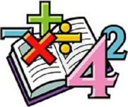  Maths  In maths we will be focusing on place value and addition and subtraction to 20. We will look at and understand numbers 11 – 20, use a number line to 20. We will look at number bonds to 20 and use the knowledge of these in our addition and subtraction calculations. | 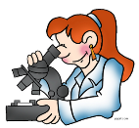  Science  We will work as scientists to learn about the plants. We will be identifying and describe the basic structure of a variety of common flowering plants, including trees. In our first Science lesson, we will plant seeds and observe them over time. | 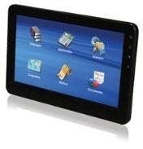  Computing  In Computing this half term, we will be looking at algorithms. We will understand that computers and devices around us use inputs and outputs. We will also understand and be able to explain what decomposition is and know how to debug an algorithm.
  Humanities  In History we will be looking at life in the 17th century -  Identifying differences and similarities between ways of life in different periods. We will explain that how people live now is different to how people lived in 1666. We will be able to describe London before, during and after the Great Fire. | 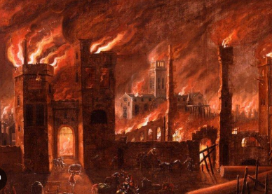  Year 1  Overdale Community Primary School  Spring term 1 2025  Big Question: Why was the fire of London called Great? |  | 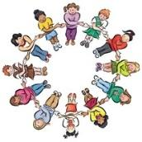  PSHE In PSHE we will be thinking about safety and the changing body. We will look at how to respond to adults and how we ca call for help in an emergency situation. We will also look at what is safe to put inside our bodies.
Art  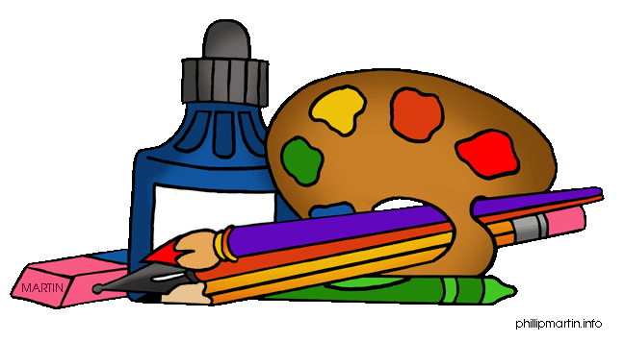  In Art this half term, we will be exploring watercolours. Looking at the work of Paul Klee & Emma Burleigh, we will understand that watercolour is a media that uses water and a pigment. | 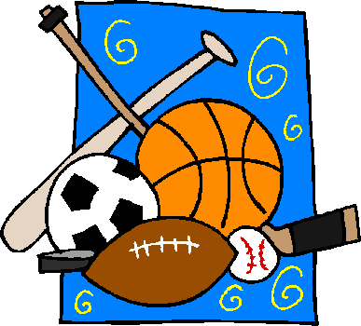  PE  In PE, our focus this half tern will be on fundamental movement skills, in particular our ball skills. We will also have bikeability lessons each week to complement our PE curriculum. |   Music In music this half term, we will be looking at high and low pitch. We will continue to have our specialist music teacher to deliver these lessons. |   RE In RE we will look at ‘What it means to belong to a faith community’ We will cover how people in the Christian, Jewish and Muslim faith show that they belong.
Reading: Children will be expected to read their home reading books three times a week with a written comment from a parent in their reading record. Children will also have access to their class Lending Library where they can bring home alternative books to read for pleasure with an adult. Some children may also start to bring home stretch and challenge books to accompany their weekly reading sessions.
Maths: To complement our learning we will be looking at the 10, 2 and 5 times tables. Any help at home with this would be greatly appreciated – thank you
Homework: Your child will continue to use their homework book. Inside the homework book is a ‘Menu’ of activities should you wish to complete. These activities are optional but do complement our learning in school.
Useful websites: https://numbots.com/ - your child has a log in for numbots https://www.bbc.co.uk/teach/supermovers/times-table-collection/z4vv6v4 - free resource
https://ttrockstars.com/ - your child has a log in for TT Rockstars

